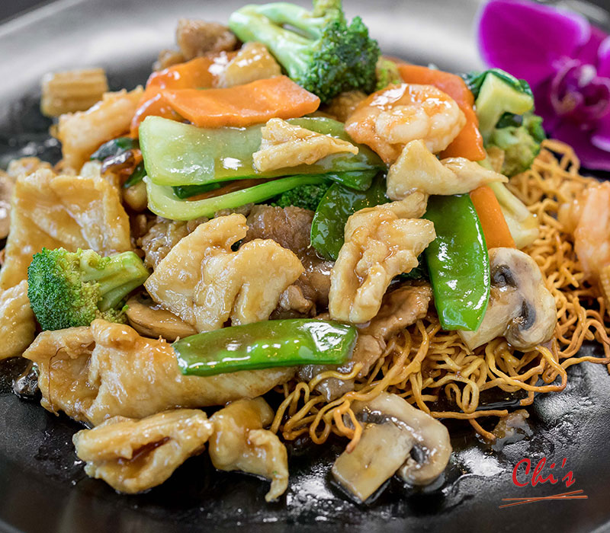


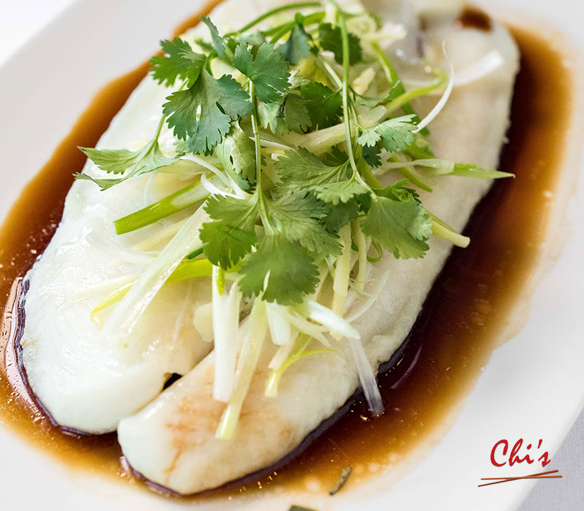
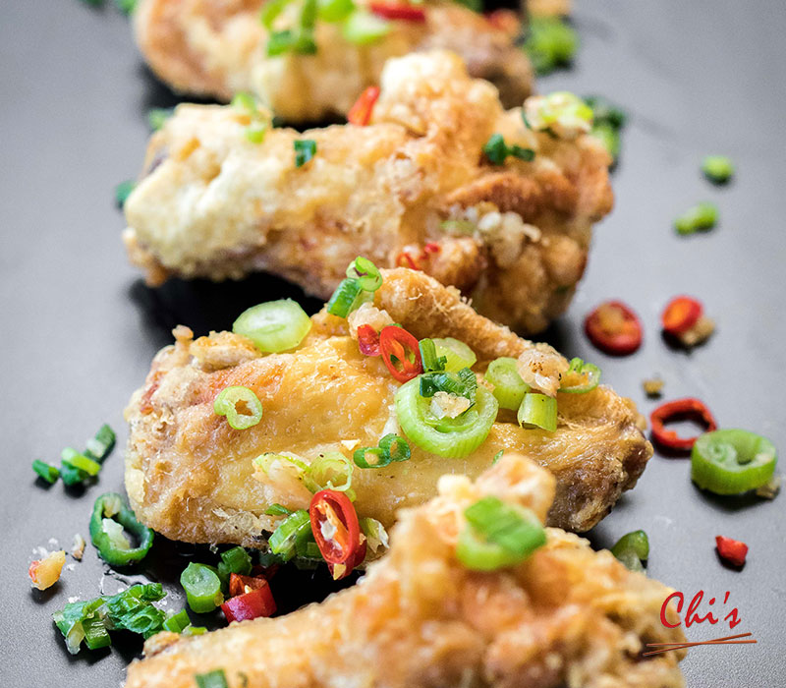
CHINESE CUISINE

Fundraiser
12/11/2024
11:00AM – 8:15PM
20% of Sales to
Castlebay Lane

Tax ID: 23-7425881
9635 Reseda Blvd.
Northridge, CA 91324
(818) 886-6928
www.chischinese.net

